Portal Box Assembly Guide

This guide explains how to assemble the Portal Box, assuming that you have a fully assembled Portal Box enclosure and an assembled Portal Box PCB. Estimated Time to Complete: 25m

# Materials & Prerequisites

* Portal Box Enclosure (3D printed - see Portal Box Enclosure Guide)
* Assembled Portal Box PCB (see Portal Box PCB Guide)
* Screws:
  + Top/LCD screen screws: 4/40 X 7/16 (8x)
  + Keypad screws: M2 X 14 (4x)
  + PCB screws: 4/40 X 1/4 (4x)
* Nuts:
  + LCD screen nuts: 4/40 X 7/16 (4x)
  + Keypad nuts: M2 X 14 (4x)
* Peripherals:
  + Portal Box Pro (User PINs & Admin Modes):
    - 4x3 Matrix Keypad (1x)
    - 16x2 RGB Character LCD (1x)
    - RGB LCD Backpack (1x)
    - MFRC522 RFID Reader (1x)
    - 5” 8 pin ribbon cables (2x)
    - STEMMA JST H 3 pin cable (1x)
  + Portal Box:
    - LED Pushbutton (1x)
    - 16x2 RGB Character LCD (1x)
    - RGB LCD Backpack (1x)
    - MFRC522 RFID Reader (1x)
    - 5” 8 pin ribbon cables (1x)
    - STEMMA JST H 3 pin cable (1x)
    - Wire (2x)
  + Portal Box Lite:
    - LED Pushbutton (1x)
    - MFRC522 RFID Reader (1x)
    - 5” 8 pin ribbon cables (1x)
    - Wire (2x)

# Assembly

PCB Installation

1. Take assembled PCB and place it in the bottom half of enclosure, aligning the power in and out ports with respective cutouts on the enclosure

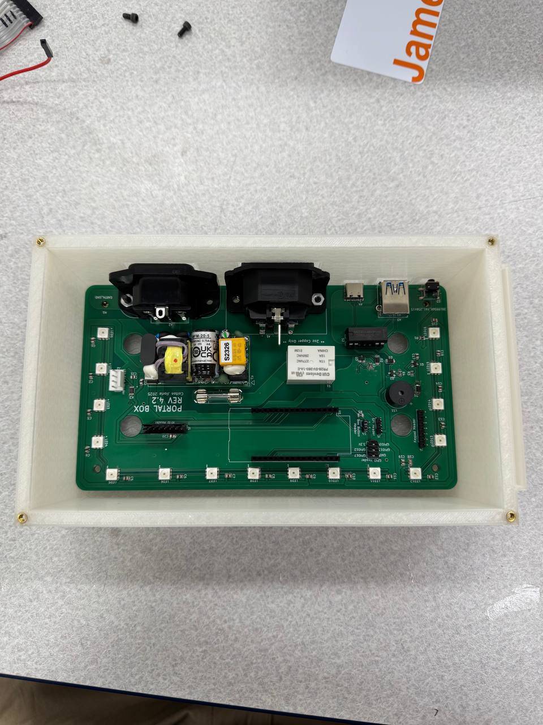

1. Insert PCB screws (4/40 X 1/4 [4x]) through PCB mounting holes and into standoffs and tighten

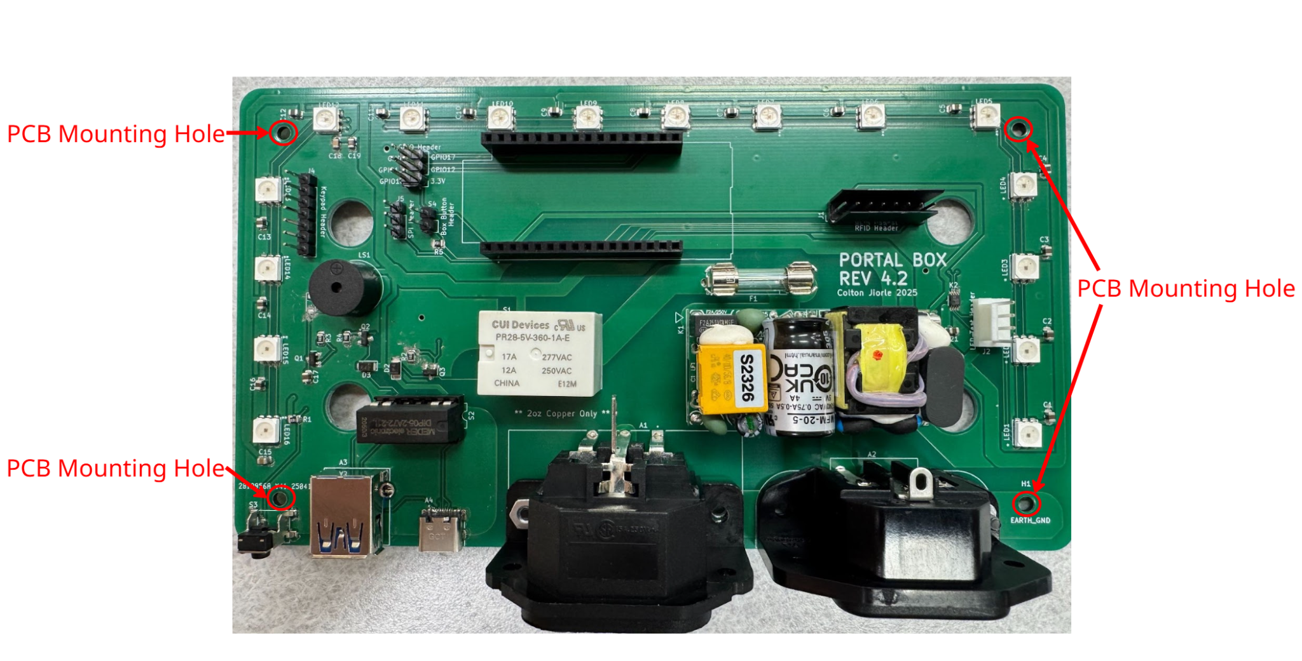

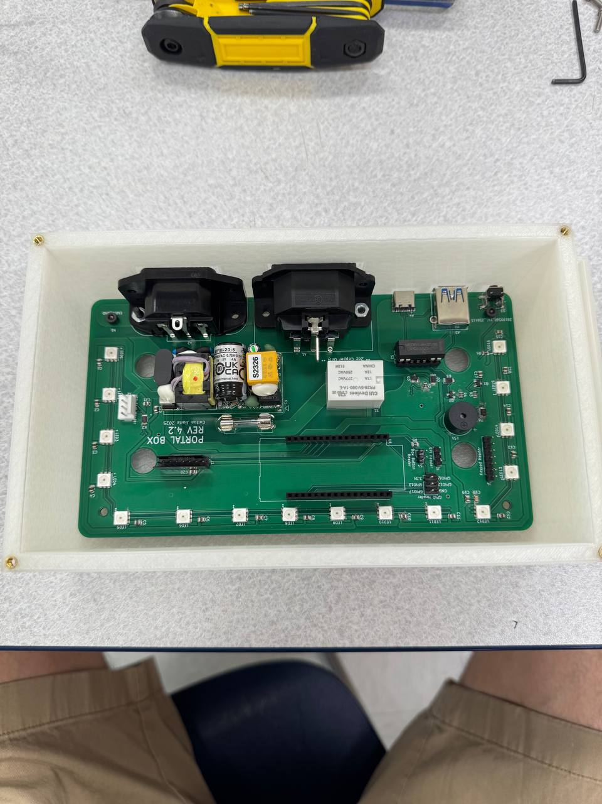

Peripheral Device Installation

1. Take the lid of the Portal Box enclosure along with the 4x3 Matrix Keypad,16x2 RGB Character LCD with RGB LCD Backpack attached and Keypad screws: M2 X 14 (4x) LCD screen screws: 4/40 X 7/16 (4x)
2. Place 4 LCD screen screws into the LCD screen mounting screw holes

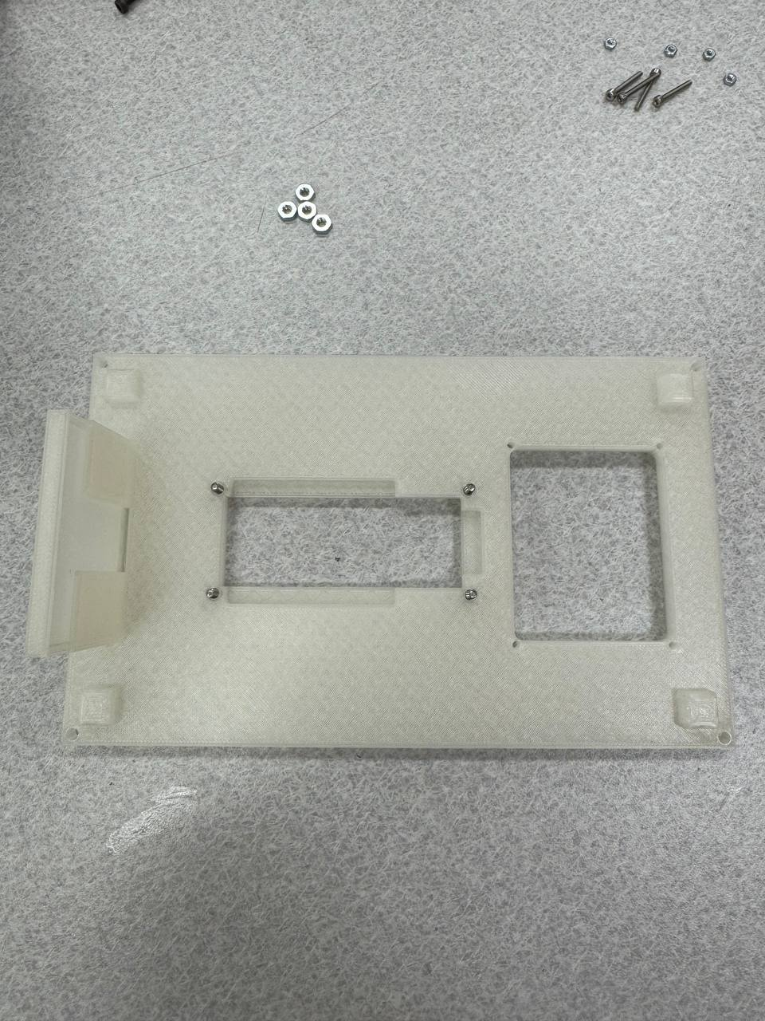

1. Place LCD screen onto screws

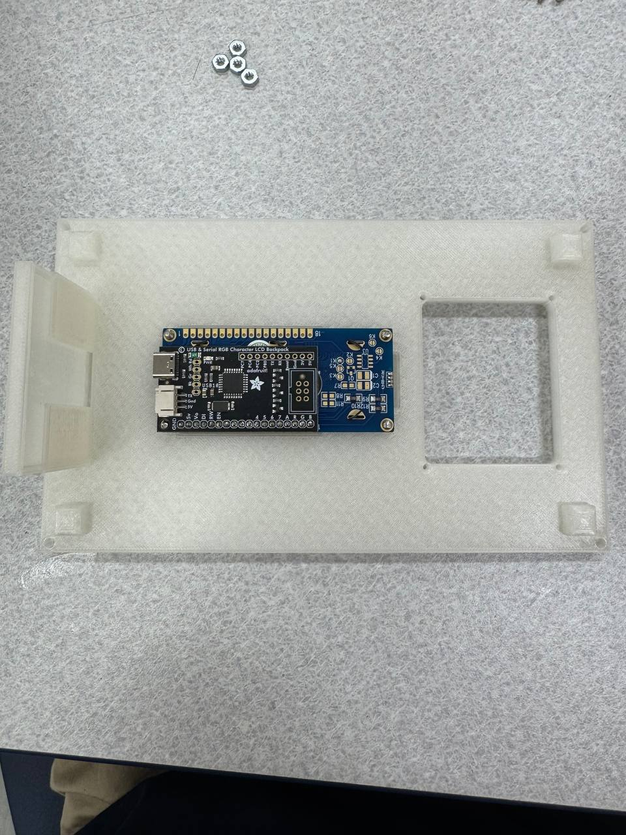

1. Place three LCD screen nuts on three visible screws and tighten

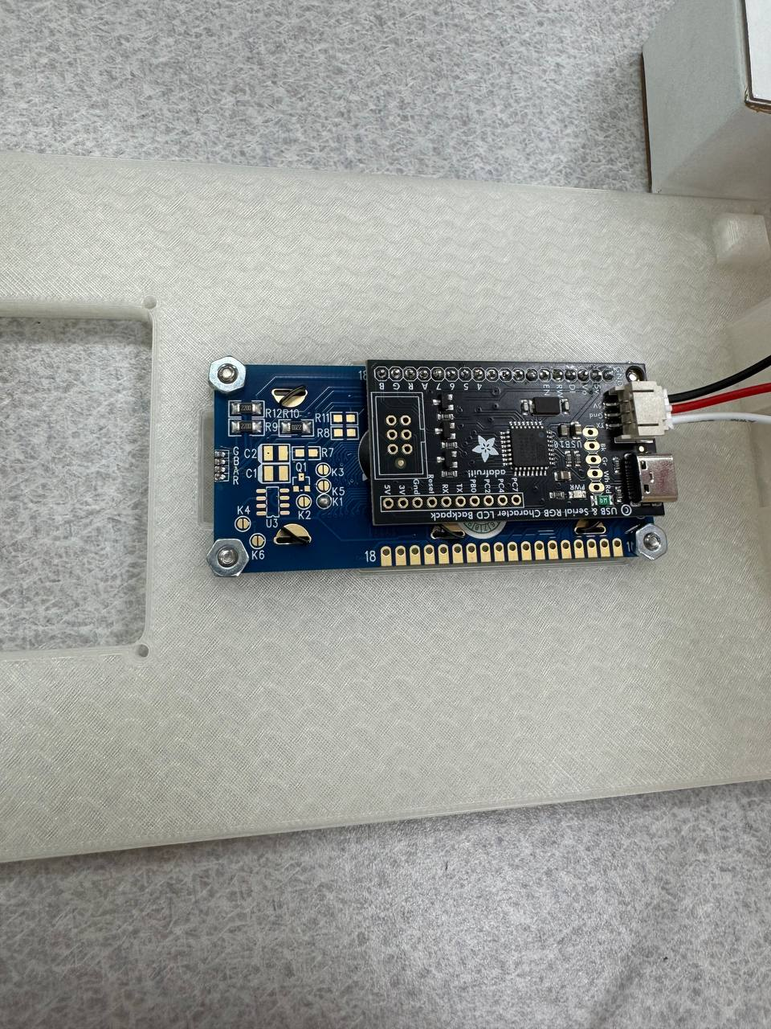

1. Place one LCD screen nut on the screw in between LCD backpack and the LCD screen and tighten

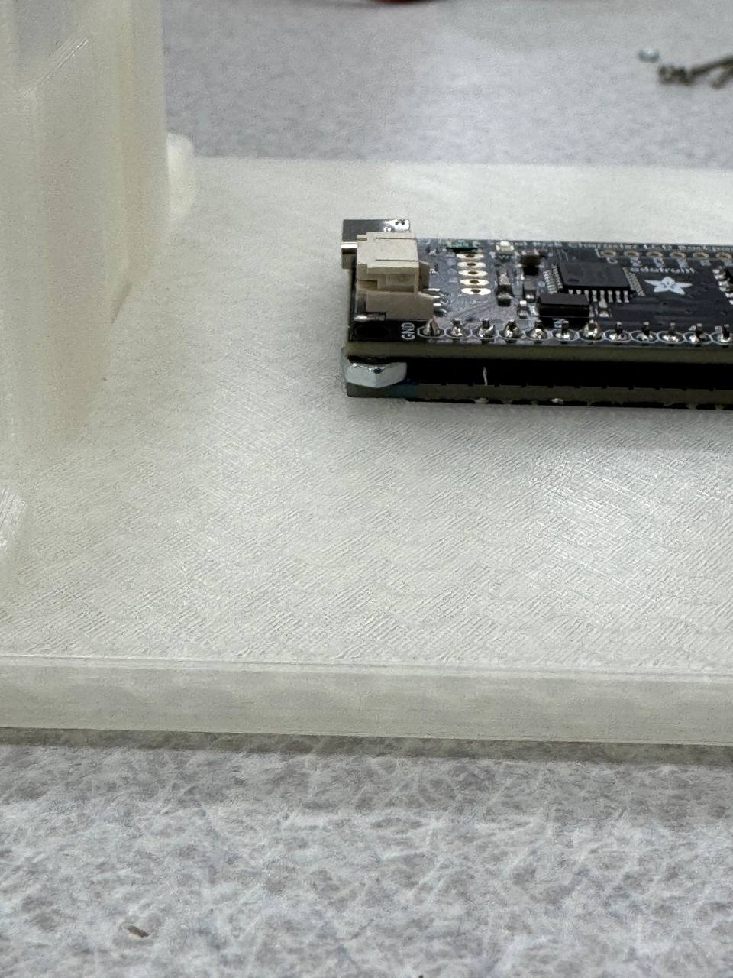

1. Place 4 Keypad screws into the Keypad mounting screw holes

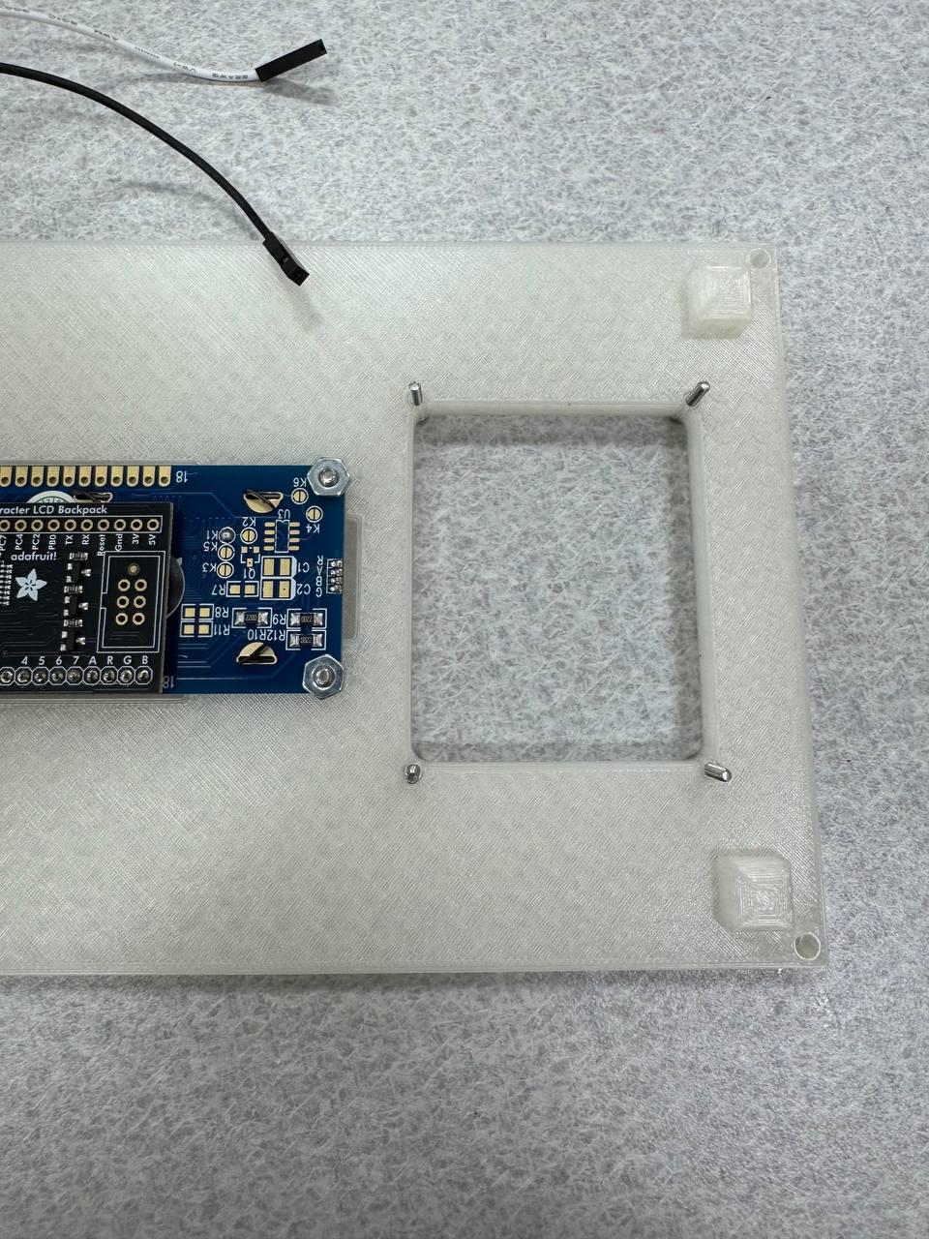

1. Place keypad onto the screws, placing the keypad pins towards the side with two visible LCD screen screws

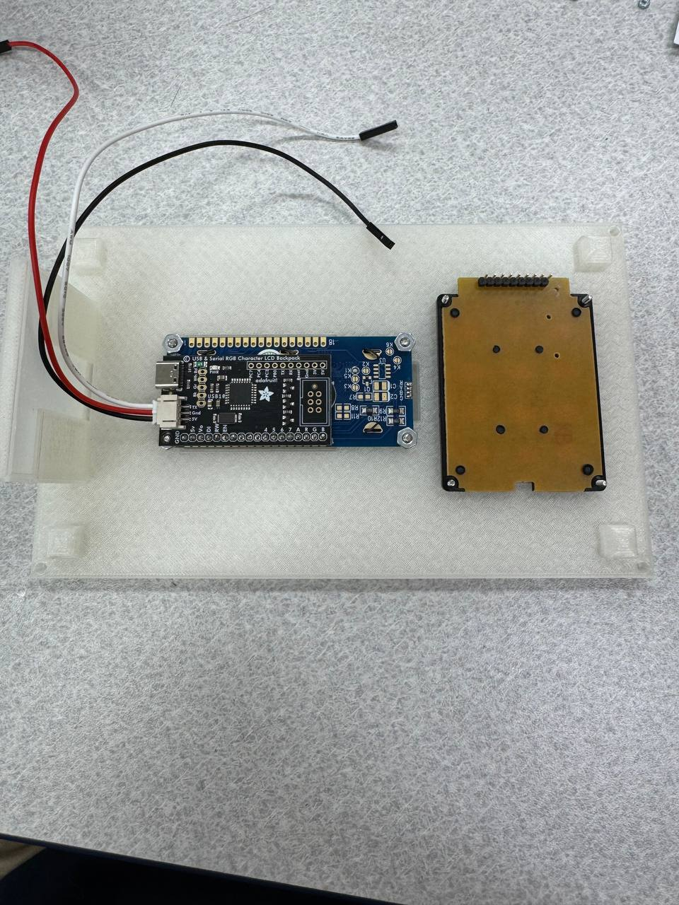

1. Place four keypad nuts on the screws and tighten

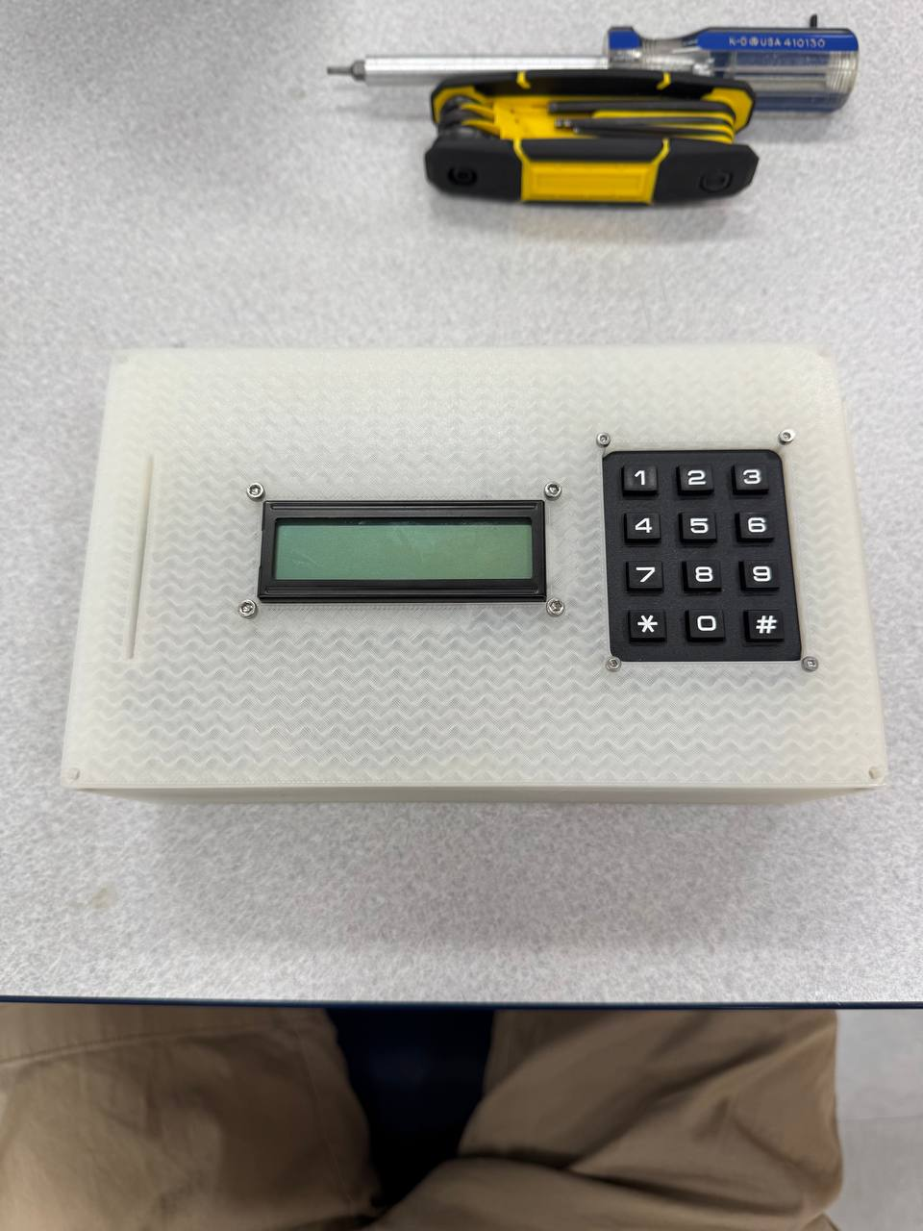

1. Slot the RFID Reader into the side of the card holder slot and use tape to secure. (Do not place tape in a way the can block the scanner, Only place near edges)

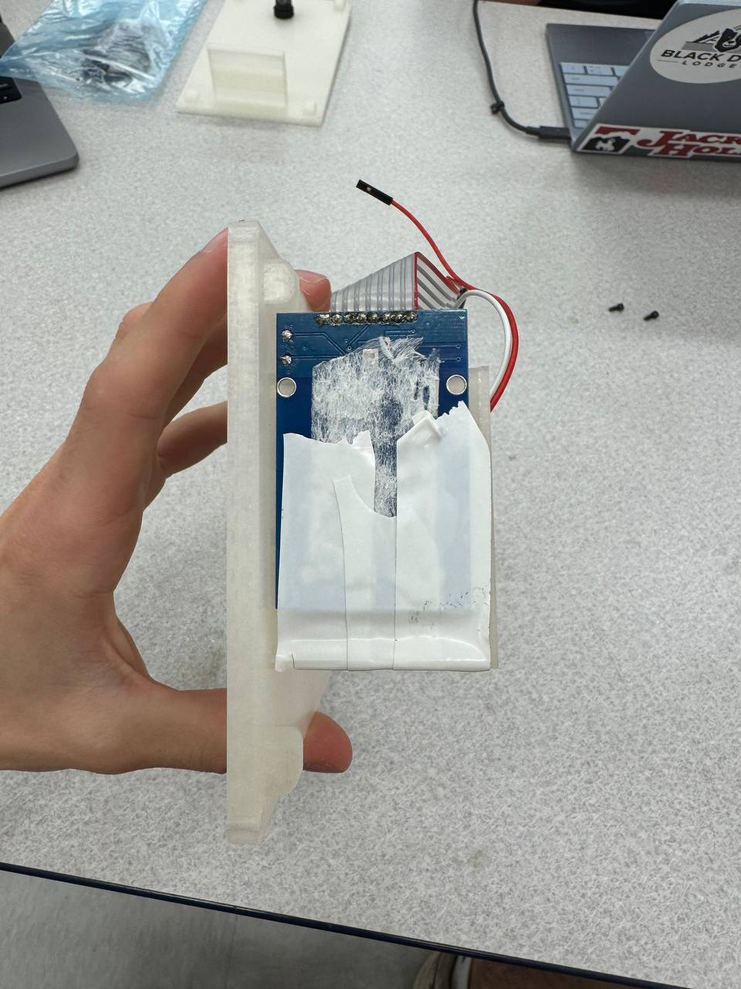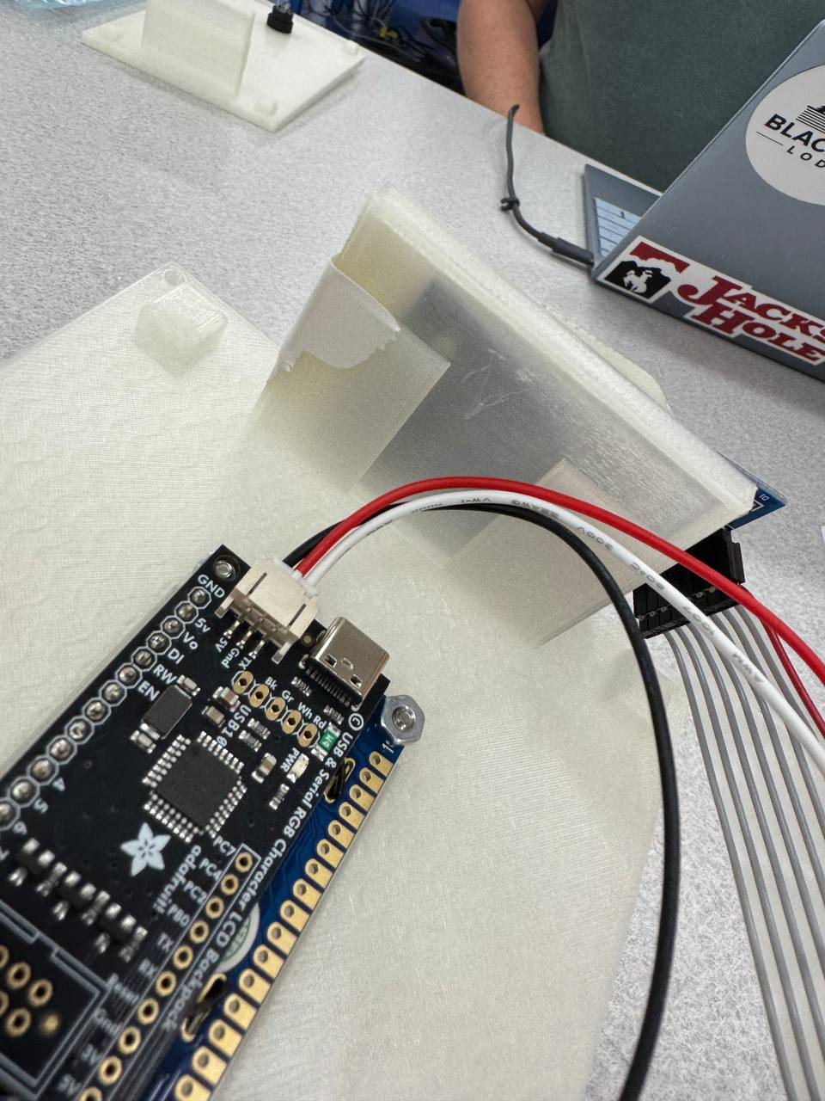

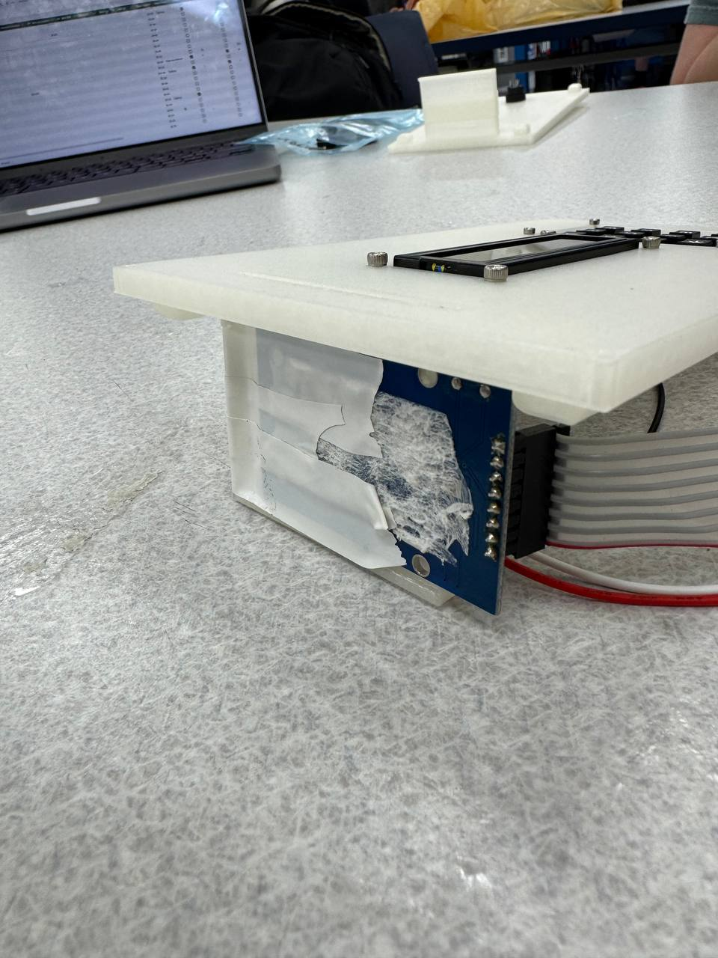

1. *If applicable* Unscrew the plastic fastener from the LED pushbutton and put the LED pushbutton through the enclosure lid. Place the plastic fastener on the back of the LED pushbutton and tighten.

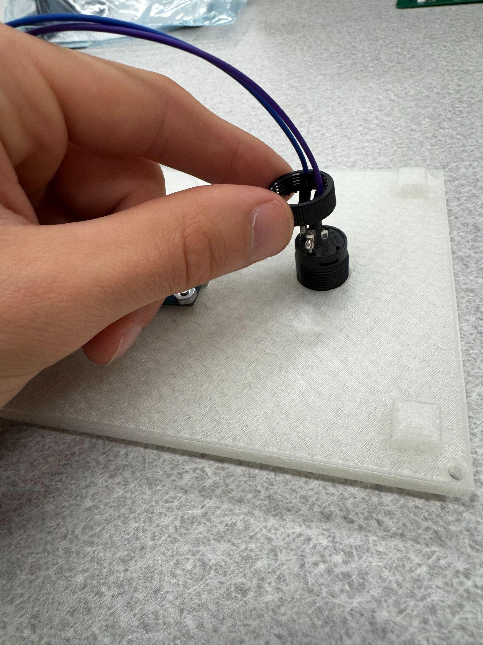

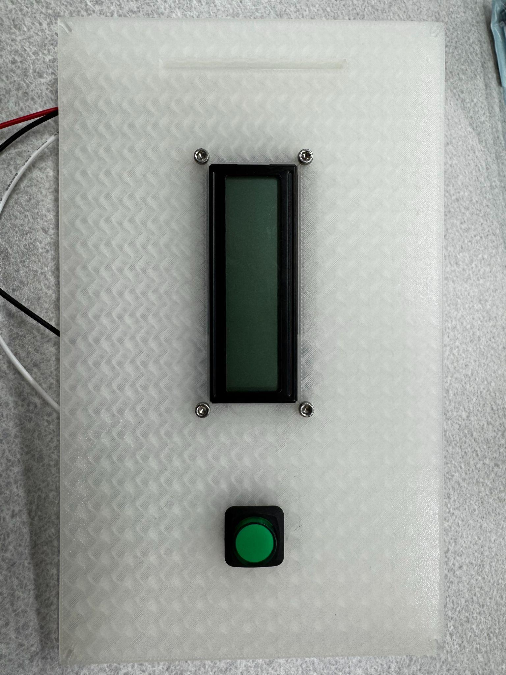

Peripheral Device Wiring

Below is a labeled PCB with no peripheral devices wired to it yet. Refer to this diagram for orientation and clarification in the following steps.

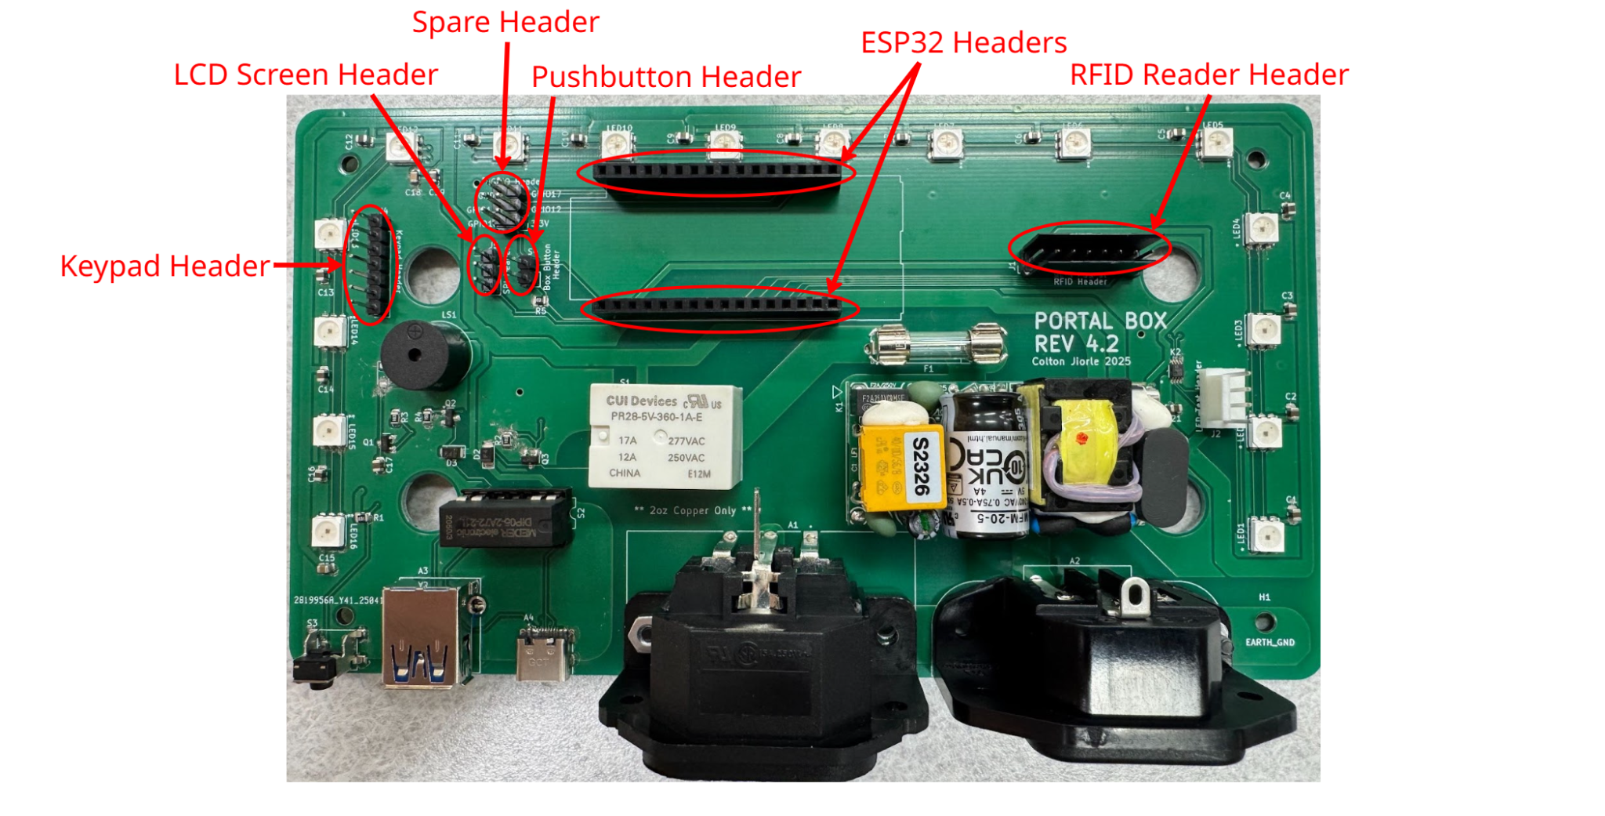

1. Begin by connecting the STEMMA JST H 3 pin cable to the LCD screen backpack



1. Connect the other side of the STEMMA JST H 3 pin cable to the LCD screen header

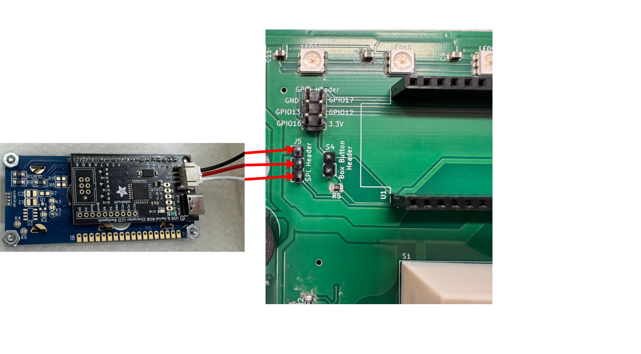

1. Next connect the 5” 8 pin ribbon cable to both the RFID reader and the Keypad
2. Connect the other end of the ribbon cable to the respective header (RFID reader to RFID reader header, Keypad to keypad header)

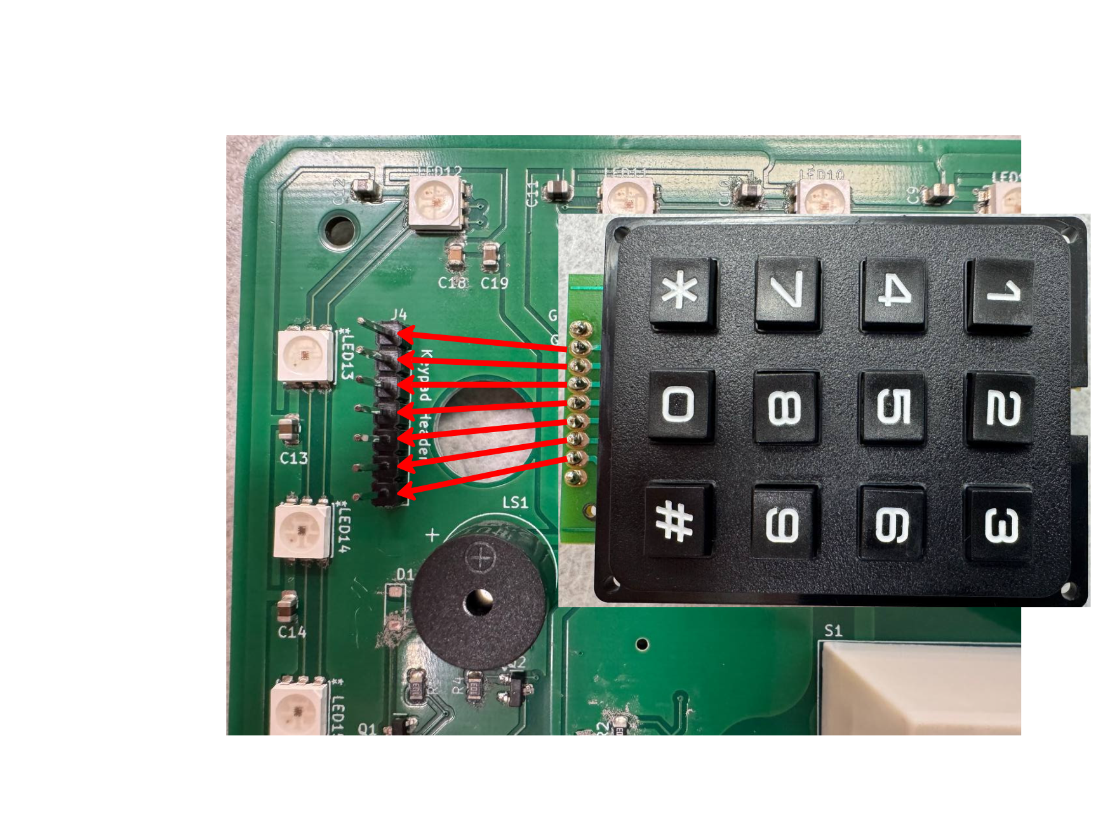

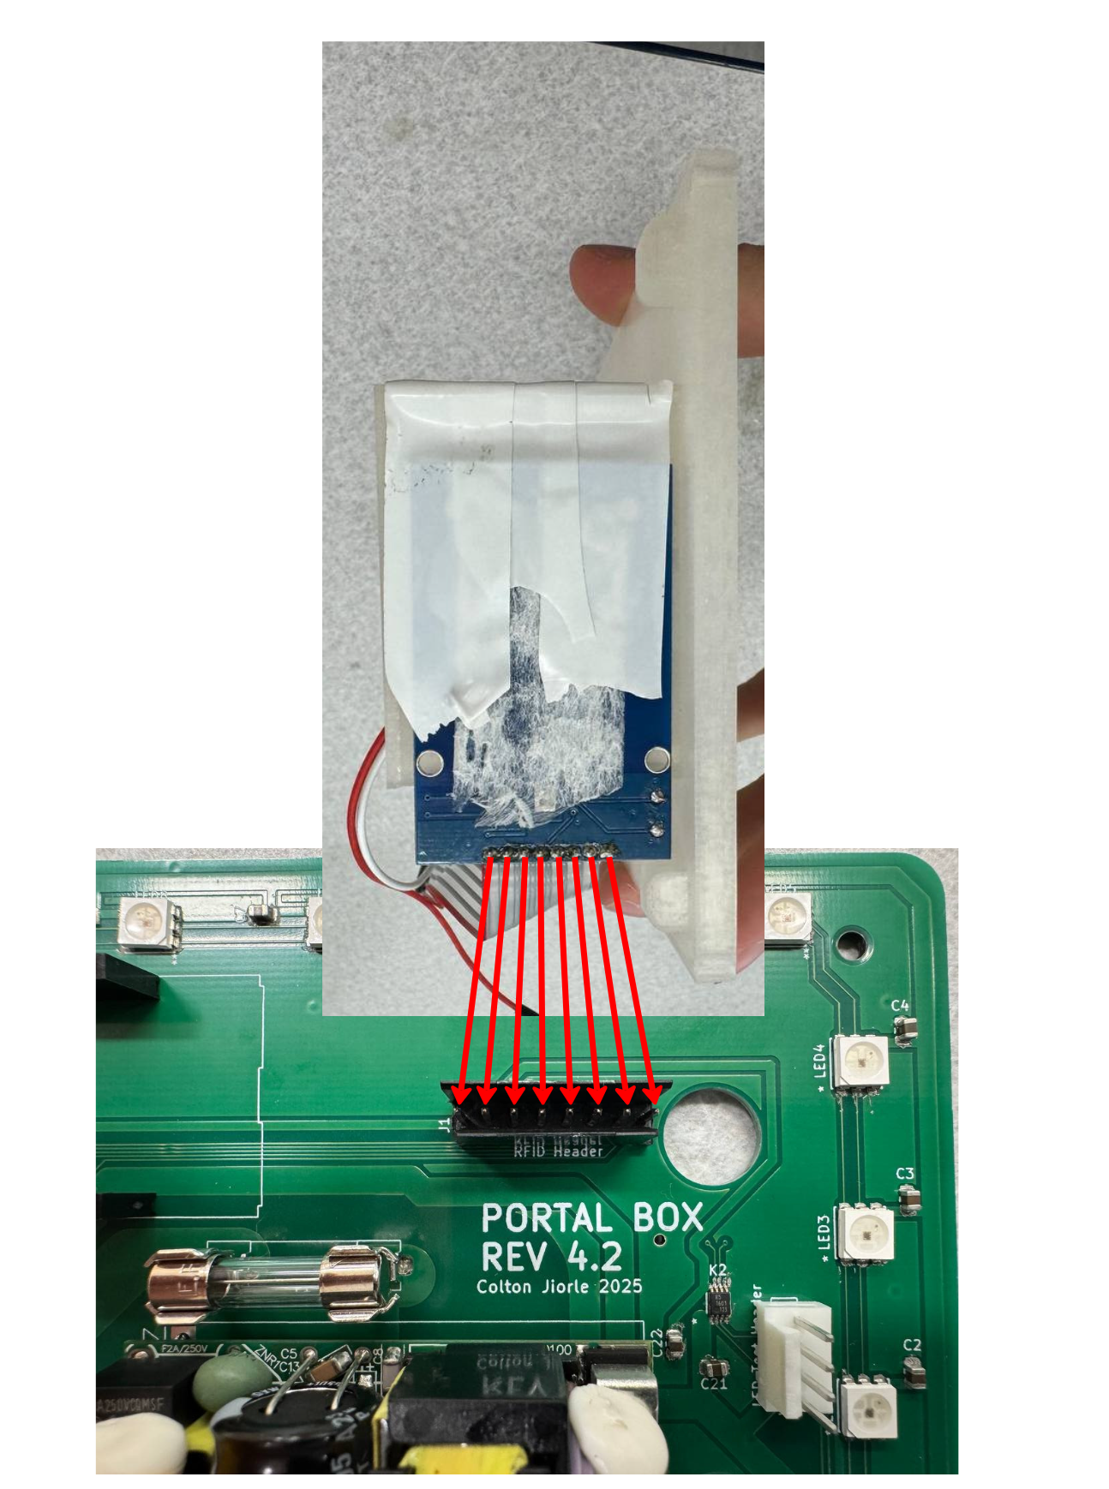

1. *If applicable* Attach the two LED pushbutton wires to the pushbutton header on the PCB.

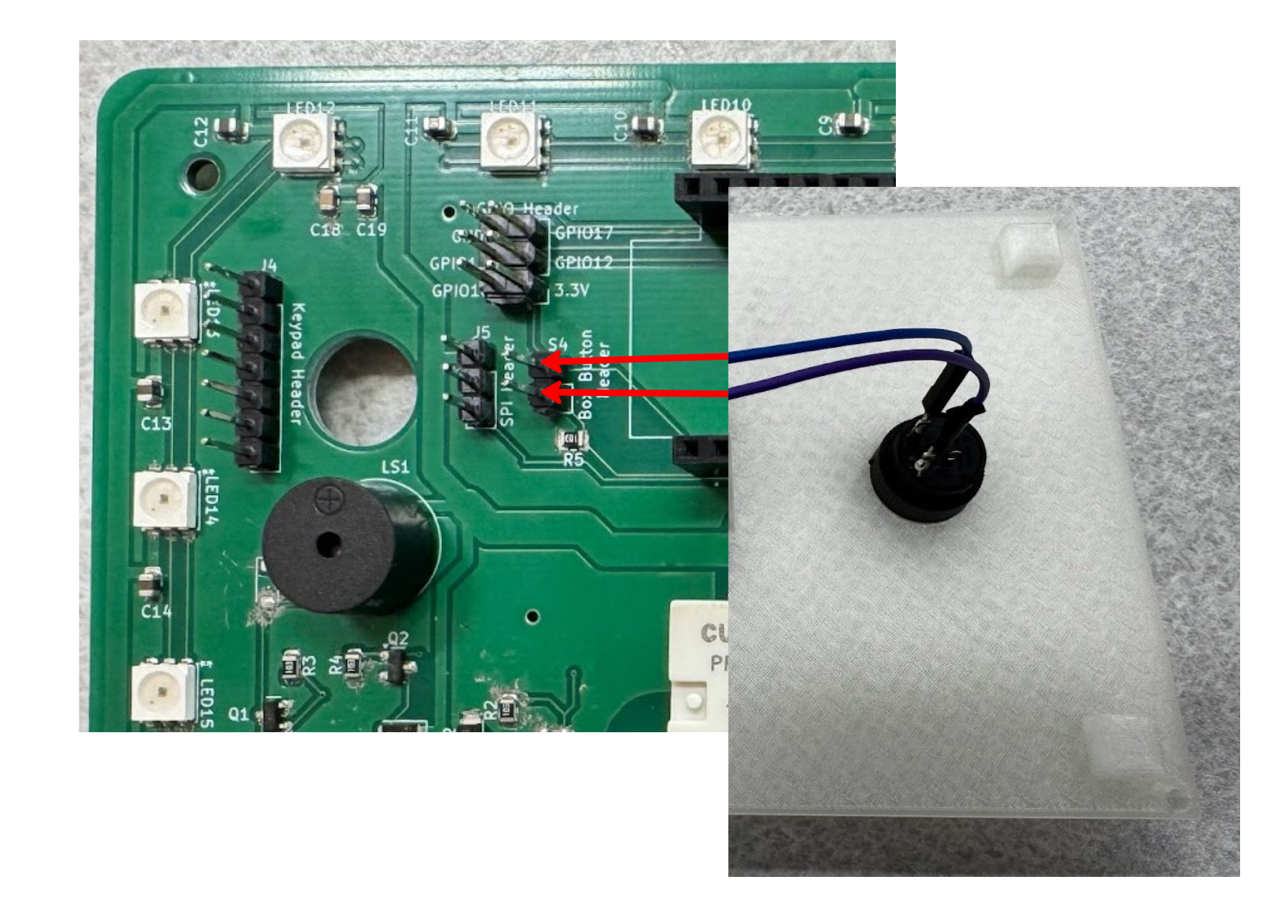

1. Connect the ESP32 microcontroller to the headers on the board following the orientation in the picture below

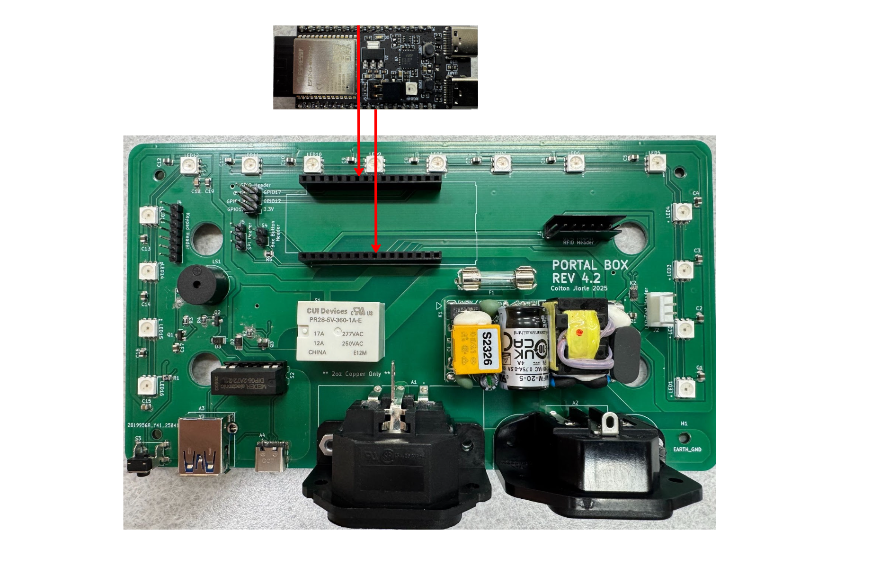

1. Ignore the spare header, nothing should be attached to it
2. Place the lid on the box ensuring all wires and connectors are inside
3. Place Top screws in each corner and tighten

